Chapter 3

Managing Projects

**Background**

This is the first chapter containing a significant amount of quantitative material. It also represents an opportunity for students to try out the popular Microsoft Project software. The concept of project crashing should be emphasized, because future managers need to know effective ways to speed up a project that has fallen behind. Note that if students will be learning about linear programming (Module B), the crashing problem can be effectively written as a linear program and solved in Excel.

**Class Discussion Ideas**

1. Ask the students to identify well-known projects that were considered failures and discuss reasons why the failures might have occurred. Examples could include certain military campaigns, engineering failures, new product introductions, etc.

2. Ask the students to describe their own experiences managing projects. What was the scope? What problems were encountered? What type of management policies and techniques were used? Were any incentives offered to team members to complete their tasks effectively? Were there incentives attached to the project as a whole?

**Active Classroom Learning Exercises**

1. A good in-class exercise to introduce project management is to have the students plan a major ‘social event” or party (i.e. Super Bowl party) and determine a WBS.

2. Developing time estimates for unfamiliar activities can be a challenge. One useful exercise might be to select a list of uncommon activities and ask students to develop the three time estimates a PERT approach would require. They should be asked to explain how and why they decided on the estimates they did and the range of estimates should be presented to the class to demonstrate the variability in this process.

3. Play the *Project Simulation Game: Rock’n Bands*. See Other Supplementary Material below.

**Company Videos**

1. *Project Management at Arnold Palmer Hospital (8:23)*

The video describes the opening of a new hospital for women and babies in Florida, precipitated by an overflow of capacity at the hospital’s current birthing facility. Planning took 13 months before construction even began. Importantly, the administration made a concerted effort to include as many voices as possible during the more than 1000 planning meetings. Managers heard from doctors, nurses, staff, patients, and community members. Three different room types were mocked up with physical models, where staff could walk in and comment about layout issues such as optimal location for electrical outlets. At the end of the video we see a shot of MS Project, which was used extensively by the hospital for this application.

Prior to showing the video, the instructor might ask the students to focus on how the hospital generated ideas for the new facility. Follow-up discussion could revolve around the importance of staff and customer inclusion, particularly when building new facilities. Given that inclusion is important, students could brainstorm about what some of the best ways might be to gather that information in a timely and cost-effective manner. The discussion might end with some student input on features of this particular project (e.g., patient comfort, staff efficiency, hotel-like atmosphere, neo-natal facility) that complicated the design requirements beyond what might be required of, say, a typical office building or even a typical hotel.

2. *Managing Hard Rock’s Rockfest (9:24)*

The video highlights Rockfest, which is an annual concert put on by Hard Rock. The concert lasts for 13 hours and is attended by over 100,000 fans. Planning for the event begins nine months ahead of time. Microsoft Project is heavily featured in this video. This project includes all kinds of very different tasks, from booking and transporting bands to providing sufficient trash facilities to working with sponsors to providing food venues to building a massive stage. One way that the firm kept things coordinated is to have periodic calls with managers of these various tasks to provide updates to and coordination with the rest of the group. One concert even had a set of Midway rides available, creating a carnival (and event in itself) within the larger event of the concert. Such an undertaking would be virtually impossible without software such as Microsoft Project.

Prior to watching the video, the instructor might ask the students to make a list of all of the different tasks that this project entails. Follow-up discussion could identify those and even brainstorm about other tasks that might not have been mentioned in the video. The instructor might ask the students what type of training or background would a successful project manager need (beyond Microsoft Project) to effectively handle all of these different tasks. What skills would a good project manager need to employ? Have any of the students in the class managed a major project? What were some of the challenges that they faced?

See Other Supplementary Material below for a case that introduces the student to Microsoft Project and project crashing based on an expansion of this Hard Rock Cafe video.

**Cinematic Ticklers**

1. *Star Wars Episode VI: Return of the Jedi (Mark Hamill, Harrison Ford, Carrie Fisher), 20th Century Fox, 1983*

At the beginning of the movie, construction on the Death Star has fallen behind. Darth Vader arrives surrounded in all his evil ambience to get them “back on schedule.”

**Presentation Slides**

INTRODUCTION (3-1 through 3-9)

Slides 8-9: From the Global Company Profile, the Bechtel group is the world’s premier manager of massive construction and engineering projects. The Bechtel projects are fascinating in their scope. The firm has clearly become a worldwide expert in successfully implementing project management concepts and techniques.



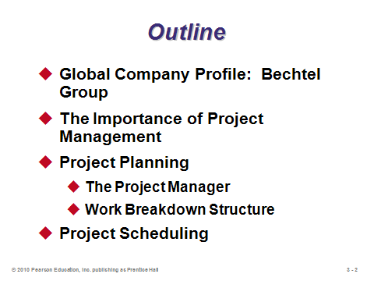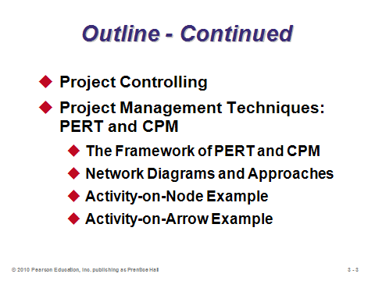

**3-1 3-2 3-3**

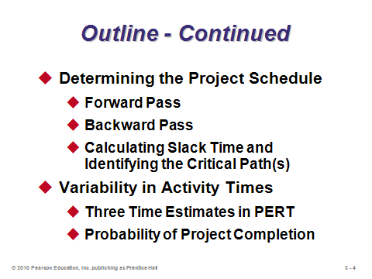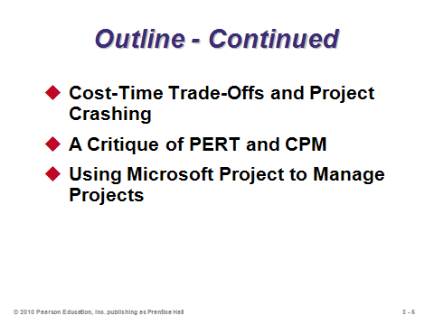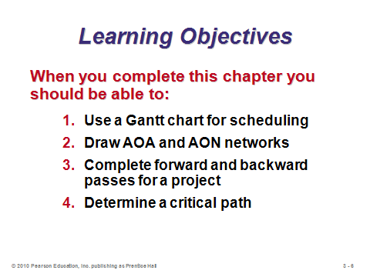

**3-4 3-5 3-6**

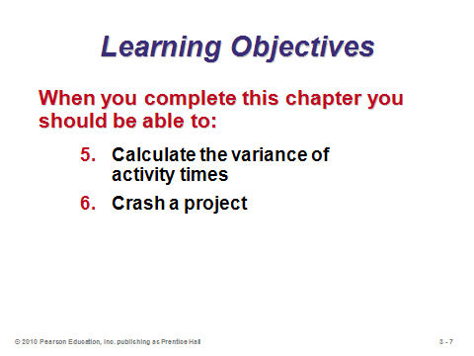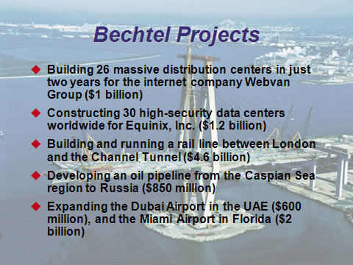

**3-7 3-8 3-9**

THE IMPORTANCE OF PROJECT MANAGEMENT (3-10 through 3-19)

Slide 10: This slide provides examples of two large-scale projects. Such efforts often require a significant amount of planning and control. Techniques and concepts introduced in this chapter, along with software such as Microsoft Project, provide important assistance.

Slides 11-12: Slide 11 identifies typical characteristics that make up a project. These can be illustrated via the two examples in Slide 12.

Slides 13-19: Project management involves the three phases identified in Slide 13 and illustrated in Slides 14 and 15-19 (Figure 3.1). Slide 19 identifies some of the tools and reports applicable to each stage.

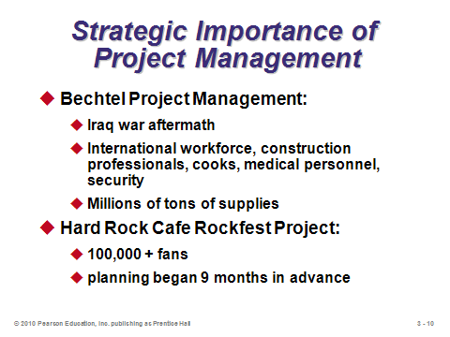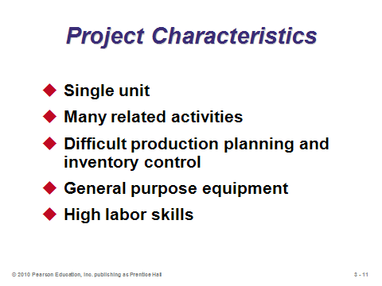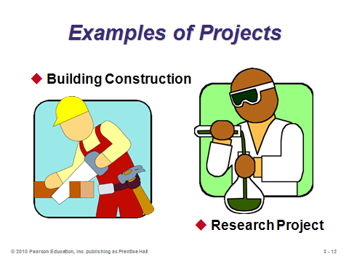

**3-10 3-11 3-12**

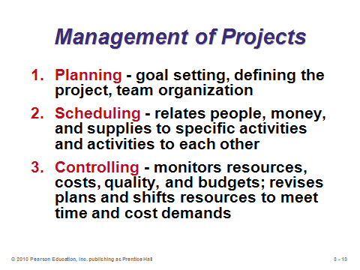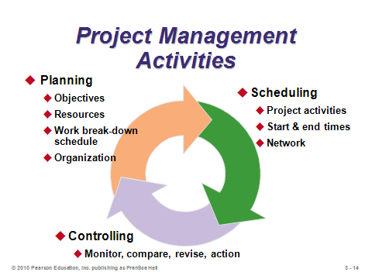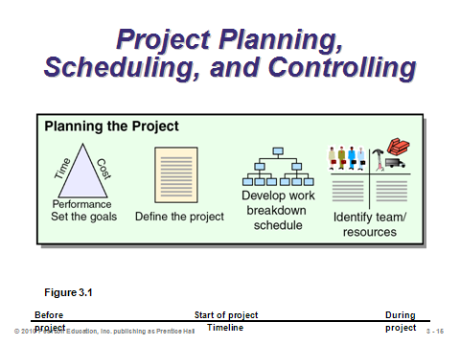

**3-13 3-14 3-15**

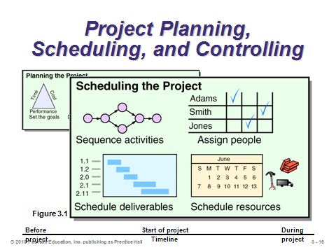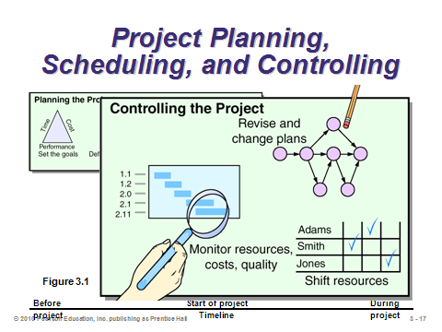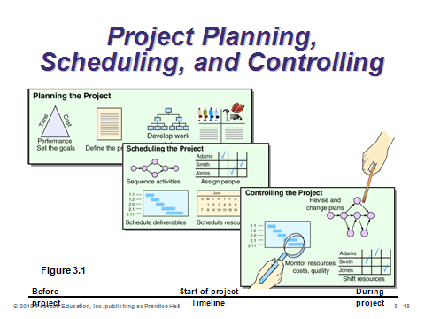

**3-16 3-17 3-18**

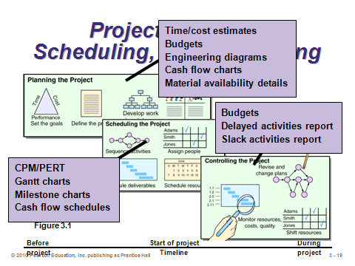

**3-19**

PROJECT PLANNING (3-20 through 3-29)

Slide 20: This slide identifies typical steps involved in project planning. A *work breakdown structure* defines the project by dividing it into its major subcomponents (or tasks), which are then subdivided into more detailed components, and finally into a set of activities and their related costs.

Slides 21-24: Slide 21 identifies typical characteristics of a *project organization*, which is an organization formed to ensure that programs (projects) receive the proper management and attention. A project organization often crosses departmental lines. The project manager’s job is often high-profile, and project success or failure is usually ultimately attributed to that person in a very public way (at least within the company). Firms managing multiple projects on a regular basis may set up a *matrix organization*. Slide 22 can be presented in reverse, that is, failed projects often lack one or more of the characteristics identified in this slide. Slide 23 (Figure 3.2) provides an example of a project organization, and Slide 24 provides an example of a matrix organization.

Slides 25-27: Good project managers need a wide variety of people, organizational, and technical skills. Slide 25 highlights the major responsibilities of a project manager, and Slide 26 follows up by identifying some of the requisite skills. This might be a good place to refer students to the OM in Action: “Docklands Light Railway (DLR): A Vital Transport Link to Woolwich Arsenal.” Slide 27 presents some of the important ethical issues that may arise in the course of a project. Research has shown that without good leadership and a strong organizational structure, most people follow their own set of ethical standards and values. The six-page Code of Ethics and Professional Conduct from the Project Management Institute can be found at the institute’s web site: http://www.pmi.org/PDF/ap_pmicodeofethics.pdf. This is a good reference for any future project manager.

Slides 28-29: The work breakdown structure typically decreases in size from top to bottom as shown in Slide 28. Slide 29 (Figure 3.3) presents a work breakdown structure illustrating the development of Microsoft’s operating system Windows 7.

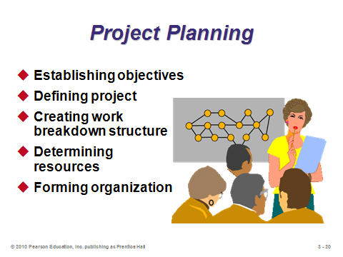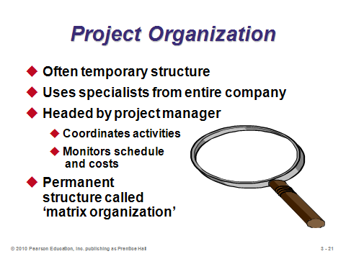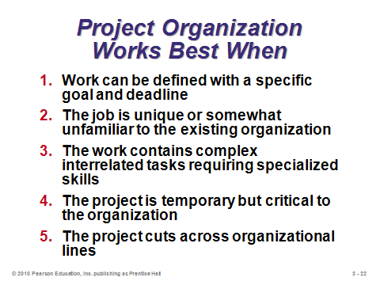

**3-20 3-21 3-22**

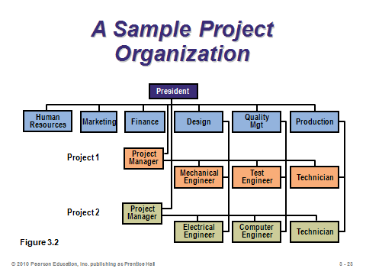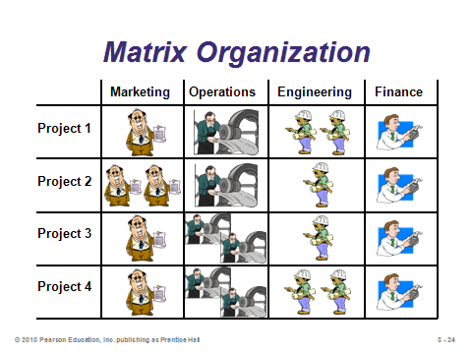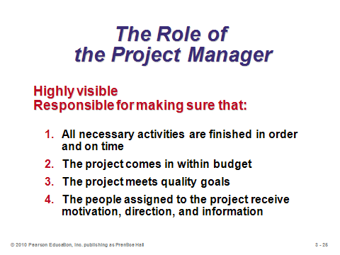

**3-23 3-24 3-25**

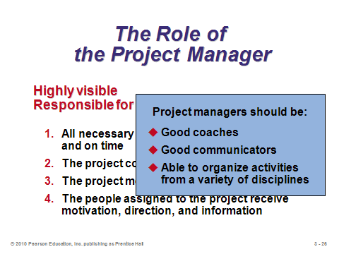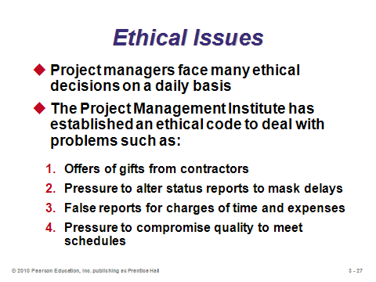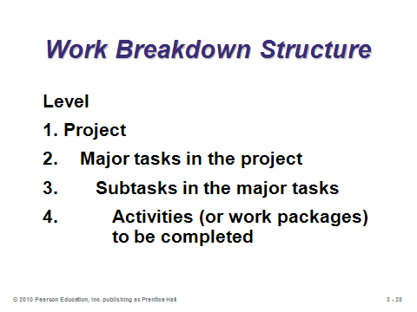

**3-26 3-27 3-28**

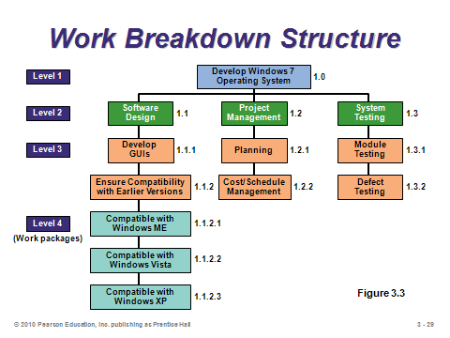

**3-29**

PROJECT SCHEDULING (3-30 through 3-35)

Slide 30: Project scheduling involves sequencing and allotting time to all project activities. This slide identifies crucial project scheduling tasks.

Slide 31: Whatever approach is taken by a project manager, project scheduling serves the purposes identified on this slide.

Slide 32: Gantt charts are low-cost means of helping managers make sure that the items identified on this slide are addressed.

Slides 33-35: While Gantt charts permit managers to observe the progress of each activity and to spot and tackle problem areas, they do not adequately illustrate the interrelationships between the activities and the resources. On the other hand, CPM and PERT *do* have the ability to consider precedence relationships and interdependency of activities. These techniques are widely used and are usually computerized. Slides 34 and 35 (Figure 3.4) present two different versions of a Gantt chart, the latter illustrating Delta’s efforts (OM in Action) to reduce its turnaround time from 60 minutes to 40.

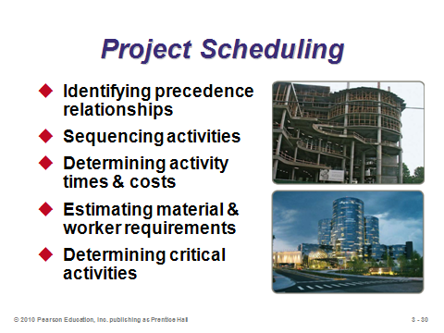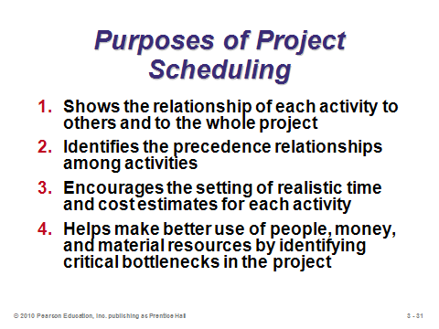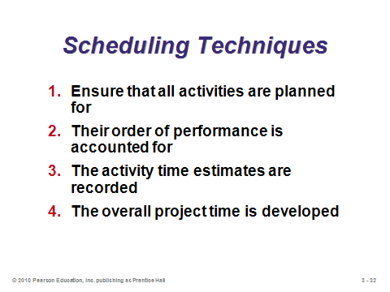

**3-30 3-31 3-32**

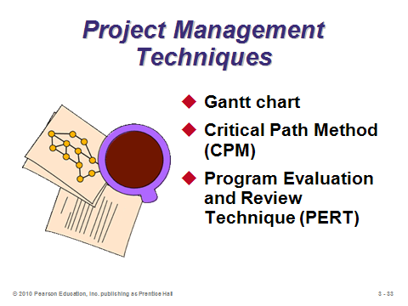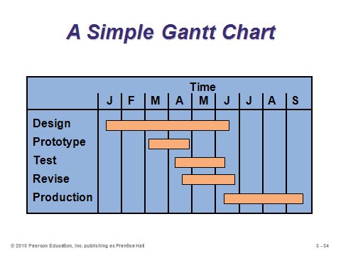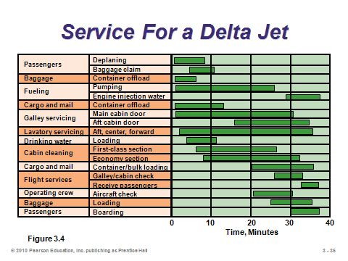

**3-33 3-34 3-35**

PROJECT CONTROLLING (3-36)

Slide 36: The control of projects involves close monitoring of resources, costs, quality, and budgets. Computerized software programs, such as Microsoft Project, produce a wide variety of reports, including the ones identified in this slide.

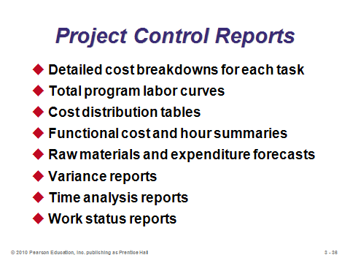

**3-36**

PROJECT MANAGEMENT TECHNIQUES: PERT AND CPM (3-37 through 3-49)

Slide 37: PERT and CPM were developed at around the same time, and most of their characteristics are the same. The major difference is that PERT incorporates uncertainty in task times by employing three time estimates for each activity (optimistic, pessimistic, and most likely). With PERT, project managers can estimate probabilities of completing the project within certain time frames.

Slides 38-39: These slides present the six basic steps of PERT/CPM. The *critical path* (Step 5) represents the expected time to complete the entire project. A delay in any activity on the critical path will delay the entire project.

Slides 40-41: Theses slides are nice because they identify eight questions that PERT and CPM can answer, even for projects with thousands of activities.

Slides 42-44: *Activity-on-node* is a network diagram in which nodes designate activities, while *activity-on-arrow* is a network diagram in which arrows designate activities. These slides (Figure 3.5) nicely illustrate how the two approaches compare under six different activity conditions. Many software packages use activity-on-node networks.

Slides 45-49: Slide 45 identifies the precedence relationships from Example 1 in the text. Slides 46-48 (Example 2) construct an activity-on-node diagram for those activities. Slide 49 (Example 3) presents an activity-on-arrow diagram for the same example.

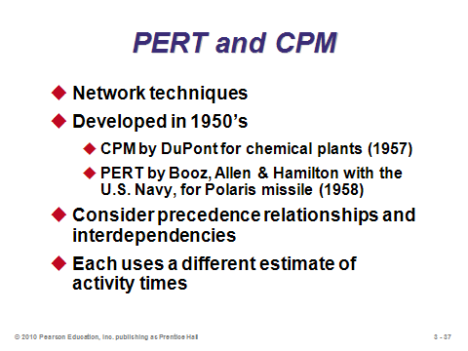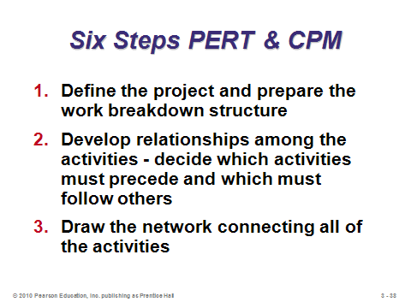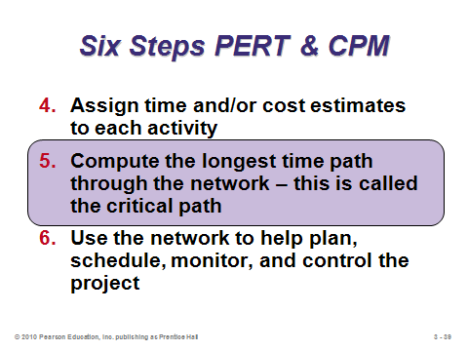

**3-37 3-38 3-39**

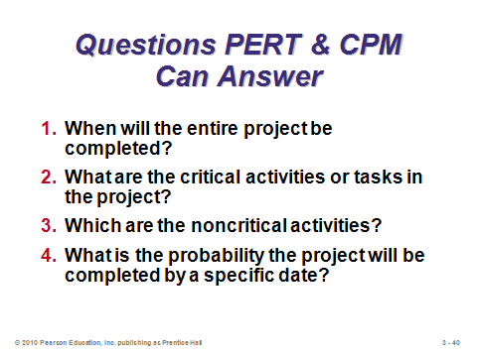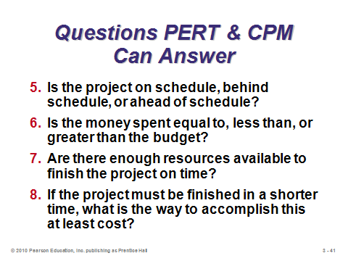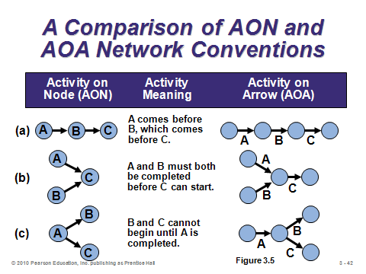

**3-40 3-41 3-42**

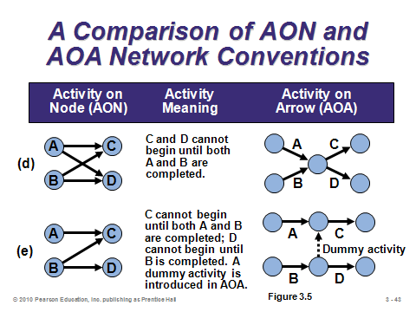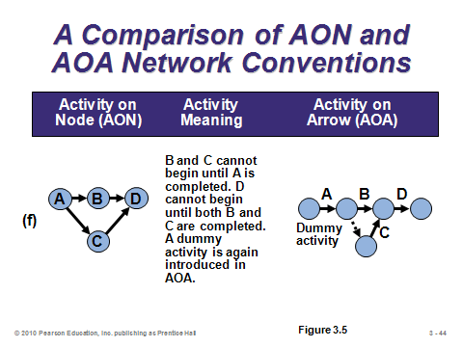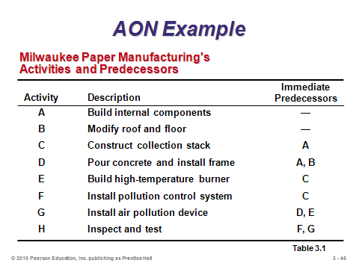

**3-43 3-44 3-45**

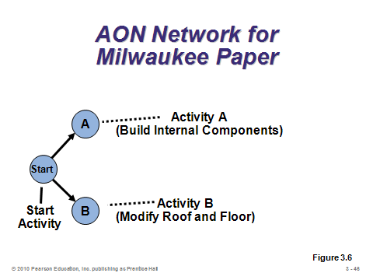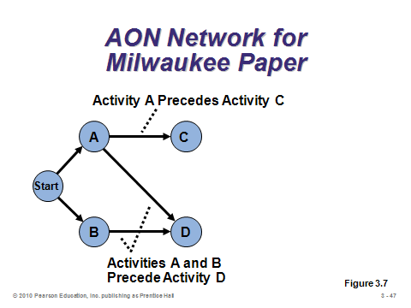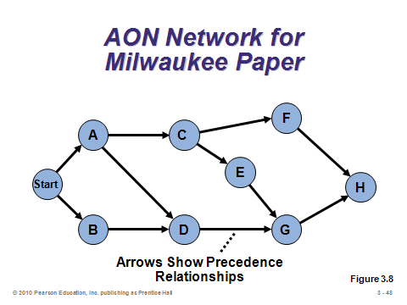

**3-46 3-47 3-48**

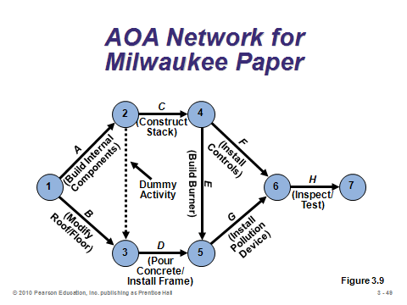

**3-49**

DETERMINING THE PROJECT SCHEDULE (3-50 through 3-73)

Slide 50: This slide describes characteristics of critical path analysis.

Slide 51: This slide contains the time estimates for the Milwaukee Paper example that will be used to illustrate critical path analysis in Slides 56-73. Note that the project will take less than 25 weeks to complete because some of the activities will be performed simultaneously.

Slides 52-53: To find the critical path, we calculate two distinct starting and ending times for each activity, as defined in Slide 52. Notation used in within nodes for the forward and backward passes is shown in Slide 53 (Figure 3.10).

Slides 54-55: These two slides present the calculations for the *earliest start* and *earliest finish* times, respectively.

Slides 56-62: For the Milwaukee Paper example, these slides (Example 4) take us through a *forward pass*, which computes all of the earliest start and earliest finish times.

Slides 63-64: These two slides present the calculations for the *latest finish* and *latest start* times, respectively.

Slides 65-68: For the Milwaukee Paper example, these slides (Example 5) take us through a *backward pass*, which computes all of the latest finish and latest start times.

Slide 69: This slide presents the calculation for *slack time*, i.e., the length of time an activity can be delayed without delaying the entire project. Activities with zero slack time are designated as *critical* and are on the critical path.

Slides 70-73: Slide 70 (Example 6) computes the slack for each activity in the ongoing Milwaukee Paper example. The activities with zero slack are marked as being on the critical path, and that path (Start-A-C-E-G-H) is identified on Slide 71. Slide 72 presents a Gantt chart for the earliest start and finish times (working on each step as soon as possible), while Slide 73 presents one for the latest start and finish times (more like a just-in-time approach).

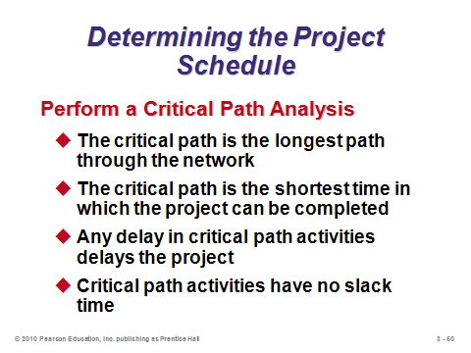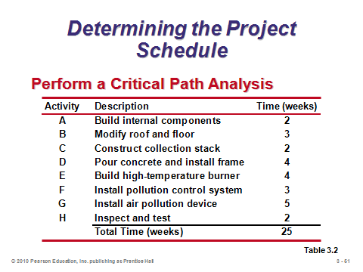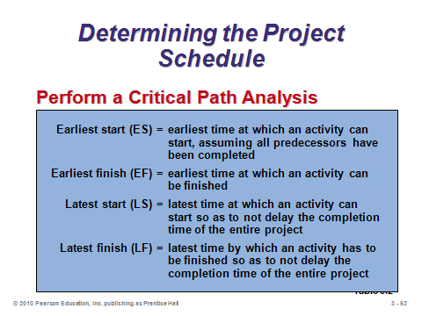

**3-50 3-51 3-52**

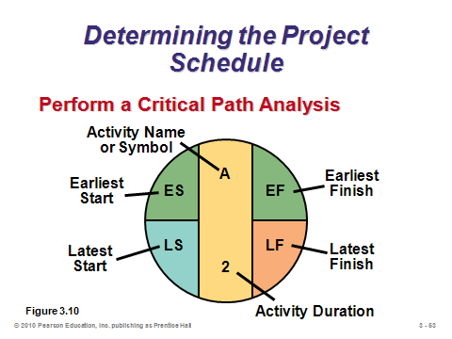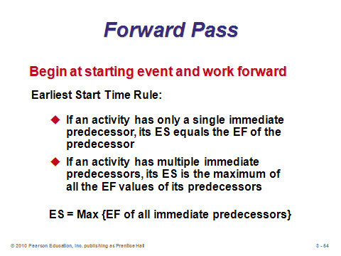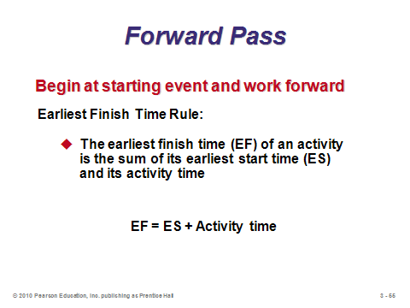

**3-53 3-54 3-55**

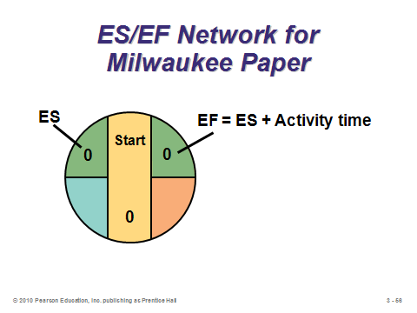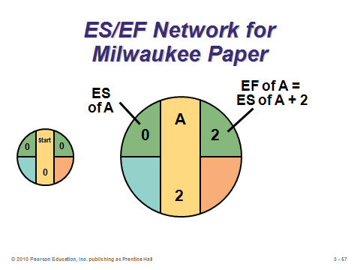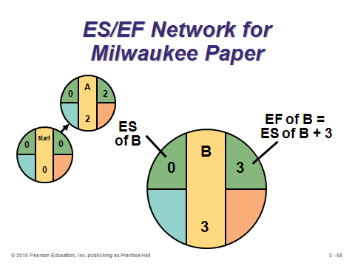

**3-56 3-57 3-58**

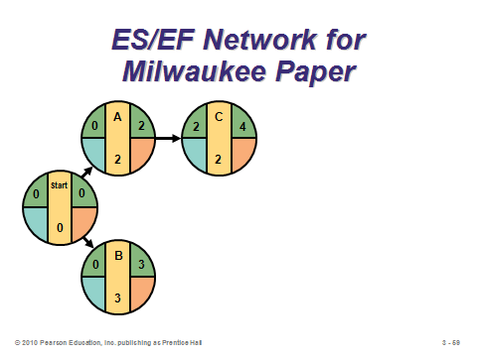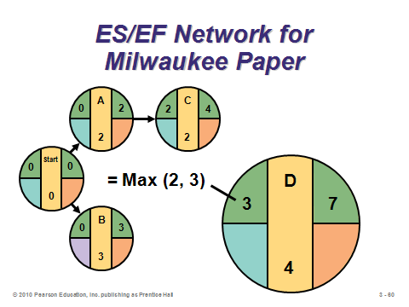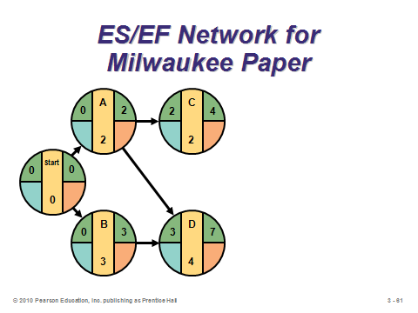

**3-59 3-60 3-61**

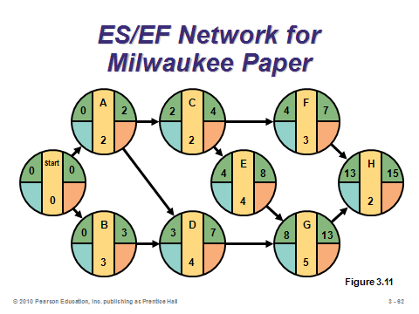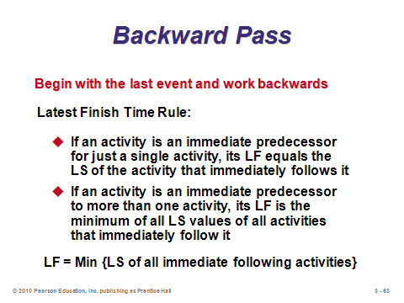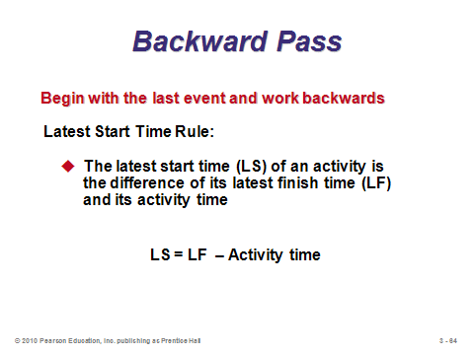

**3-62 3-63 3-64**

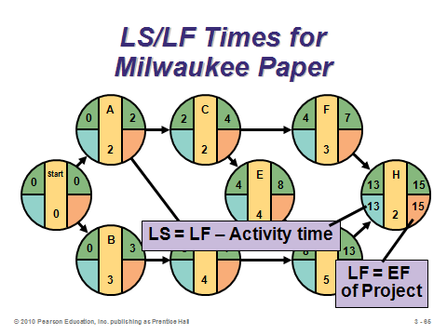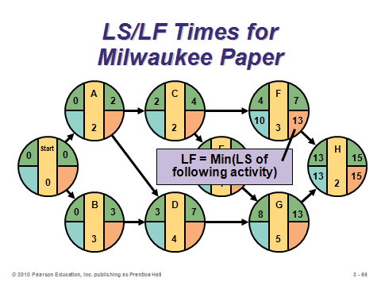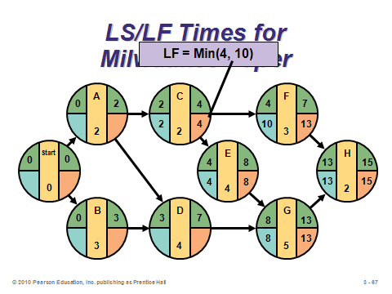

**3-65 3-66 3-67**

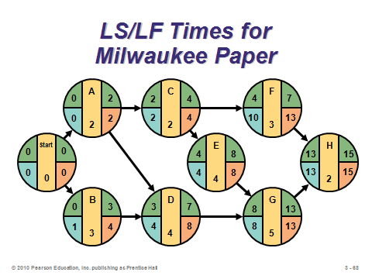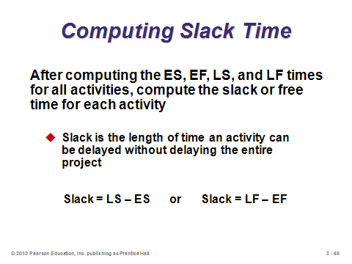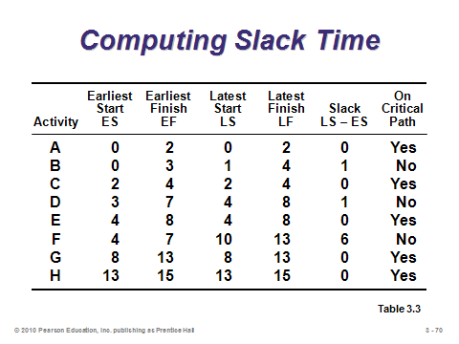

**3-68 3-69 3-70**

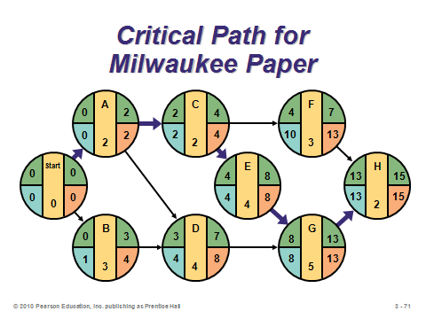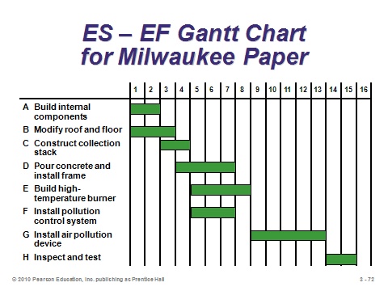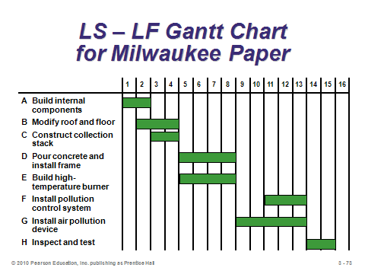

**3-71 3-72 3-73**

VARIABILITY IN ACTIVITY TIMES (3-74 through 3-88)

Slides 74-75: PERT introduces the common occurrence of activity time uncertainty, which may be particularly applicable for a new project incorporating new activities or personnel. The manager is asked to provide best-case, worst-case, and most likely time estimates for each activity.

Slides 76-77: We often assume that the PERT time estimates follow a beta probability distribution, as pictured in Slide 77 (Figure 3.12). Using the three time estimates, Slide 76 presents the calculations for the expected time and the variance of times. Note that the *expected time* will not equal the *most likely time* if the optimistic and pessimistic times are not equidistant from the most likely time. Slide 77 reminds us that the optimistic and pessimistic times should be chosen such that there should only be about a 1% chance of the activity actually taking shorter than or longer than those two times, respectively.

Slide 78: This slide (Example 8) applies PERT to the ongoing Milwaukee Paper example, computing an expected time and variance for each activity. Notice when the expected times are different from the most likely times and when they are the same. Also notice that the size of the variance is directly related to the spread between the optimistic and pessimistic times and has nothing to do with the most likely time.

Slides 79-80: Slide 79 presents the formula for the variance of the entire project. By assuming that the activities are *independent*, this value is simply the sum of the individual activities on the critical path. (In reality, the independence assumption may well not apply, and, importantly, ignoring the variance of noncritical activities may underestimate the true project variance.) Slide 80 (Example 9) computes the project variance for the ongoing Milwaukee Paper example.

Slides 81-82: The assumptions identified in Slide 81 can be used to help answer questions regarding the probability of finishing the project on time. For example, the probability distribution for project completion times for the ongoing Milwaukee Paper example is drawn in Slide 82 (Figure 3.13.).

Slides 83-85: These slides (Example 10) show how to determine the probability of completing the ongoing Milwaukee Paper example by the 16-week deadline. The Standard Normal Distribution Table (Appendix I) converts the computed Z-value into the desired probability.

Slide 86: The probability calculation can be applied in reverse to determine the due date necessary to provide a given probability of completing the project on time. This slide from Example 11 in the text illustrates that idea for a 99% probability of completing the ongoing Milwaukee Paper example. From the Normal Table, the *Z*-value needs to be 2.33. With that value, the due date needs to be set no earlier than expected completion time + (*Z* × *σp*) = 15 + (2.33 × 1.76) = 19.1 weeks.

Slide 87: This slide reminds us that, especially when noncritical activities have a small slack, the variability of noncritical activities should be considered as well. It may be useful to compute the variability in completion times of noncritical paths (which is done in the same way as the variability computation for the critical path).

Slide 88: This slide summarizes the major results from the ongoing Milwaukee Paper example up to this point in the presentation.

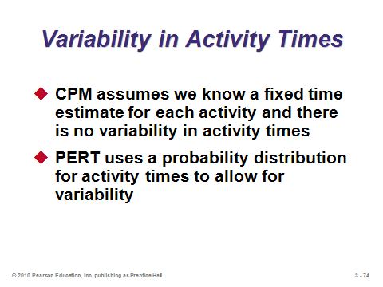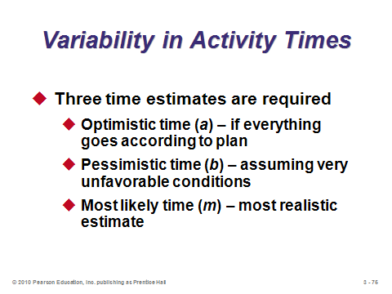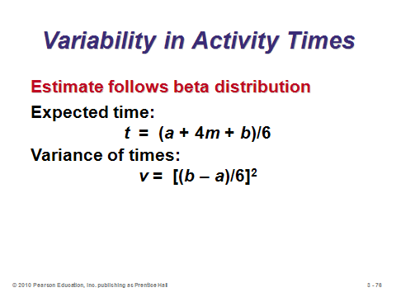

**3-74 3-75 3-76**

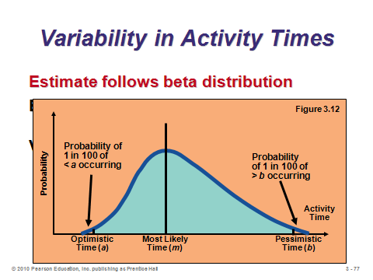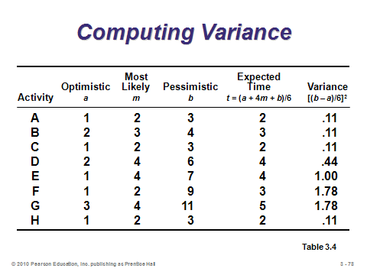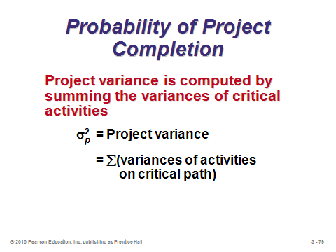

**3-77 3-78 3-79**

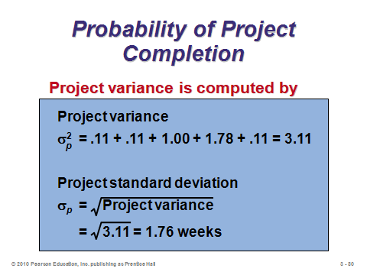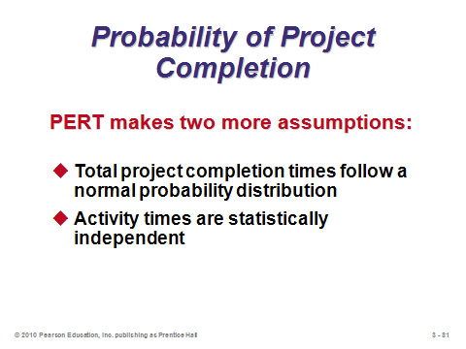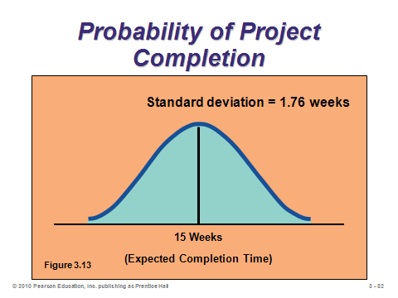

**3-80 3-81 3-82**

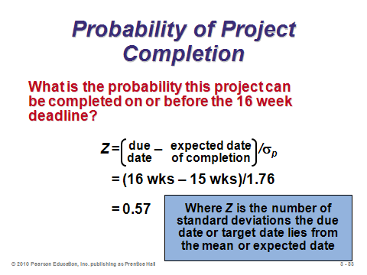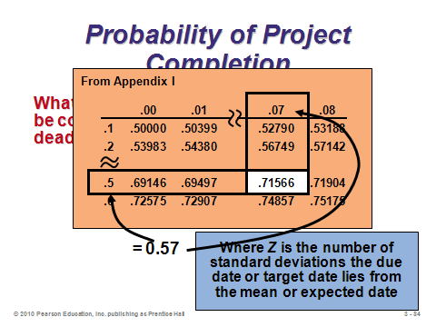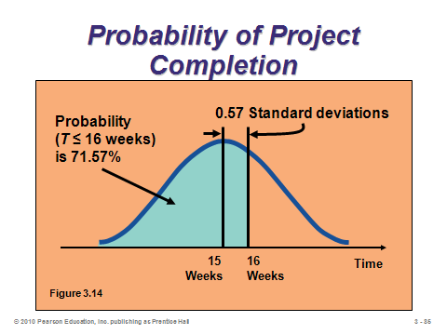

**3-83 3-84 3-85**

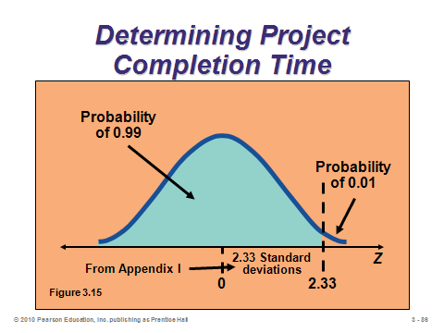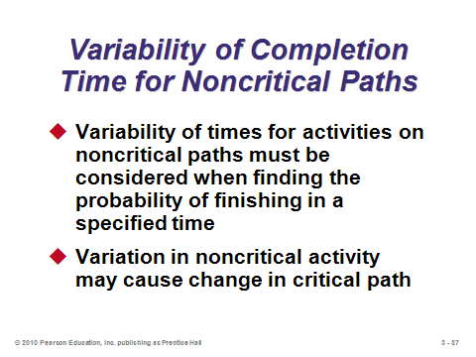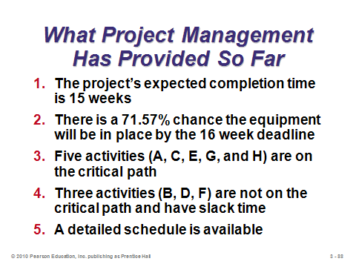

**3-86 3-87 3-88**

COST-TIME TRADE-OFFS AND PROJECT CRASHING (3-89 through 3-96)

Slide 89: *Crashing* involves finding ways to shorten project activity times to speed up the overall project completion time. Why is this important? Construction projects, in particular, often carry huge penalties for each day late (see the $10,000 penalty per day late in the *Southwestern University: (A)* case at the end of the chapter).

Slide 90: Managers are usually interested in speeding up a project at the least additional cost. Hence, when choosing which activities to crash and by how much, they need to consider the factors identified on this slide.

Slides 91-93: These slides describe the steps to take to crash a project. It should be noted that a new path may become critical during the solution algorithm. If so, it needs to be taken into consideration in future steps.

Slides 94-96: These slides (Example 12) show how to crash the ongoing Milwaukee Paper example by two weeks. Slide 94 presents the data. Slide 95 shows how to compute the crash time for Activity B. Slide 96 presents the original network for reference. In the example, Activity A should be crashed first at a cost of $750. This creates a second critical path: Start-B-D-G-H. The second activity to be crashed by a week should be Activity G at a cost of $1500. Even though its crash cost per period is larger than that of the smallest eligible activities on each of the two critical paths, Activity G is chosen because it lies on both paths; thus, both path times are reduced by a week when Activity G is reduced by a week.

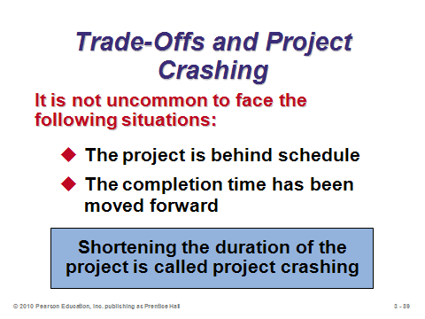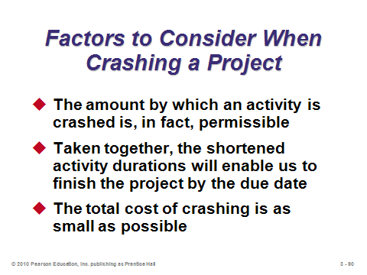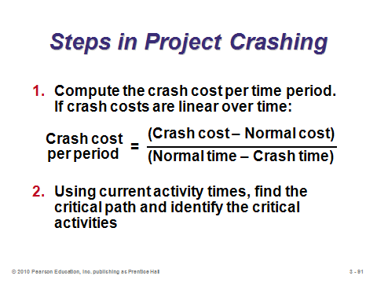

**3-89 3-90 3-91**

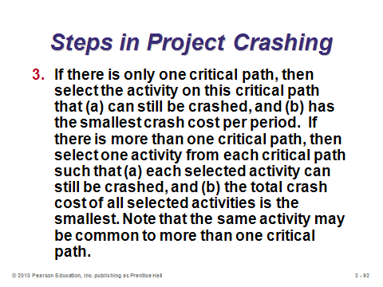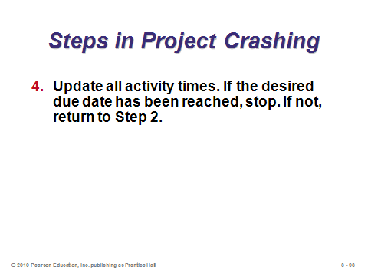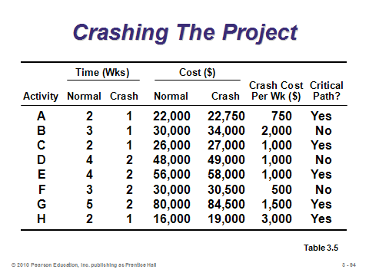

**3-92 3-93 3-94**

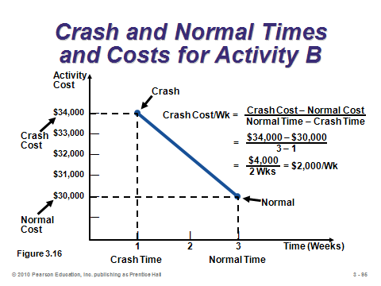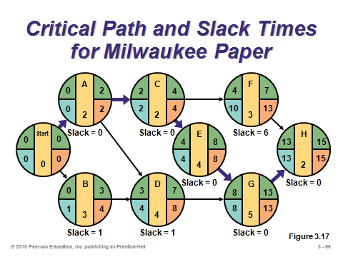

**3-95 3-96**

A CRITIQUE OF PERT AND CPM (3-97 through 3-99)

Slides 97-99: Slides 97 and 98 identify advantages of PERT/CPM, while Slide 99 provides important limitations. Clearly for projects involving hundreds or thousands of activities, it can be difficult to accurately identify the activities, their characteristics, and their precedence relationships.

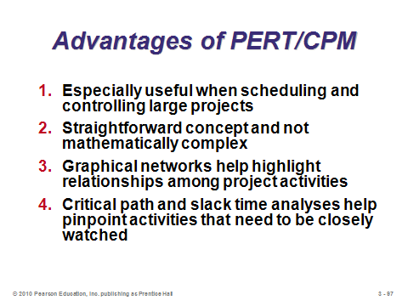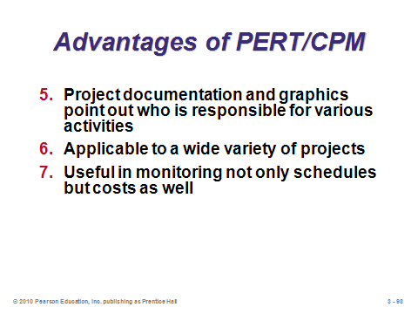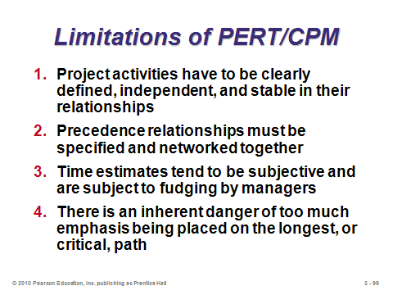

**3-97 3-98 3-99**

USING MICROSOFT PROJECT TO MANAGE PROJECTS (3-100 through 3-103)

Slide 100: This slide identifies several popular project management software packages.

Slides 101-103: These slides analyze the ongoing Milwaukee Paper example using Microsoft Project. Slide 101 (Program 3.1) shows a Gantt chart. Slide 102 (Program 3.2) shows the schedule as a project network, with the critical path identified in red. Clicking on an individual activity displays its details. Slide 103 shows the monitoring capabilities of the software. After about six weeks, three activities (A, B, and C) have been completed but three others (D, E, and F) are behind schedule.

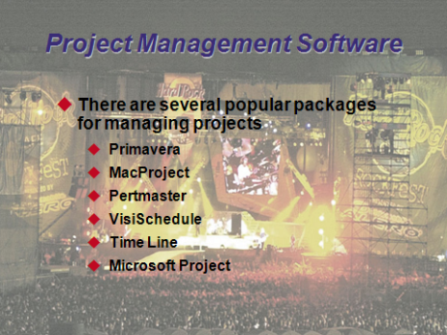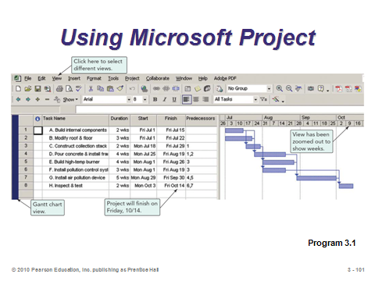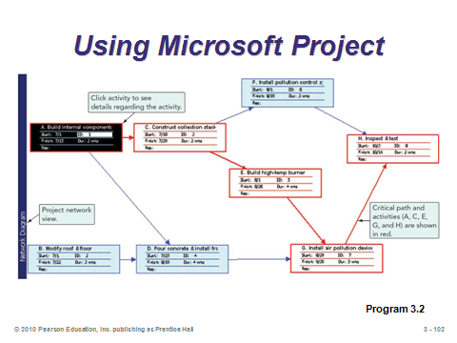

**3-100 3-101 3-102**

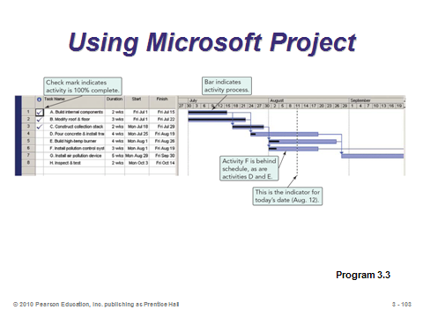

**3-103**

**Additional Assignment Ideas**

1. If the students have a major term project for the class, they might try applying some of the tools from this chapter to help them manage the preparation and submission of their assignment. This activity would be especially useful if the project was team-based.

2. Search the Internet for consulting or engineering organizations (other than Bechtel) that offer project management skills and support to clients. Typically, these will have a description of a few of the firm’s more outstanding success stories. Describe two of these examples. (One possibility is Gardiner and Theobald (www.gardiner.com/).)

**Additional Case Studies**

*Hard Rock Concert Case* (see Other Supplementary Material below)

Internet Case Study (www.pearsonglobaleditions.com/heizer)

* *Shale Oil Company*: This oil refinery must shut down for maintenance of a major piece of equipment.

Harvard Case Studies (http://harvardbusinessonline.hbsp.harvard.edu)

* *Microsoft Office 2000* (#600-097): An analysis of the evolution of the Office 2000 project.
* *Chrysler and BMW: Tritec Engine Joint Venture* (#600-004): A gifted project leader defines a new product strategy.
* *BAE Automated Systems (A): Denver International Baggage Handling System* (#396-311): The project management of this construction of Denver's baggage-handling system.
* *Turner Construction Co*. (#190-128): Deals with the project management control system at a construction company.

Richard Ivey School of Business (http://cases.ivey.uwo.ca/cases/pages/home.aspx)

* *Waterloo Regional Police Services: Reassessing the CIMS Project* (#9B07E010): It had been four years since the chief of the Waterloo Regional Police Services (WRPS) met with the board to discuss critical next steps regarding vendor management for the Common Information Management System (CIMS) project. Since then, considerably more resources had been invested into the CIMS project by all stakeholders involved. The relationship with the current vendor, ITG, was growing less productive and the chief knew it was time to reassess the project to determine the best next steps toward successful project implementation.

**Internet Resources**

|  |  |
| --- | --- |
| E-Business Solutions for project management | www.eprojectcentral.com |
| PERT Chart EXPERT is an add-on product for Microsoft Project that adds extensive PERT charting | www.criticaltools.com |
| PERT Chart and WBS add-on products for Microsoft Project | www.criticaltools.com |
| Project Management Forum | www.pmforum.org |
| Project Management Institute, Inc. | www.pmi.org |
| Project Management Software | www.project-management-software.org |
| Project workspace for the construction industry | www.buzzsaw.com |
| Project time collection | www.journeyx.com |

**Other Supplementary Material**

Additional Qualitative Content

Operations management research papers and books tend to focus on the quantitative aspects of project management, but the “management” aspects of it are equally important. Text material could be supplemented with some of this type of material, if desired. For example, traits of successful project managers include: scheduling (PERT/CPM), budgeting, allocating human and material resources, contracting, measuring work performance, monitoring quality, performing risk analysis, negotiating, managing change, displaying political savvy, possessing a high tolerance for ambiguity, exhibiting cost consciousness, being results oriented and practical, showing commitment, having a good head for details, understanding project goals thoroughly, understanding staff needs, and being able to cope with setbacks and disappointments. Causes of failed projects might include: poor definition of the project and objectives, lack of relevant data, shortage of technical know-how, political factors, unproven design modifications, insufficient inspection and quality assurance, invisibility of project management, bad organization and personnel, imperfect information handling, inadequate risk management, no team spirit, and lack of maintenance and training. Finally, time management strategies could be discussed as well.

**Case**

**Teaching Note**

**Project Crashing Using MSProject**

**Hard Rock Concert Case**

Prepared by Gary LaPoint, School of Management, Syracuse University

**Purpose:** This case introduces the student to MS Project and project crashing via MS Project. It is an expansion (to 33 activities) of the video case study, “Managing Hard Rock’s Rock Fest,” at the end of Chapter 3. Using MS Project, students input the tasks, start date, identify the holidays, and determine which activities they are going to crash. Some prior instruction in navigating through MS Project will likely be required. A 45-minute lab session in a computer cluster may be appropriate prior to using this exercise.

The files that include the activities under normal conditions (***Hardrock Before.Mpp***) and the activities under crash conditions (and ***Hardrock After.Mpp***) for MSProject are on the Instructor’s CD.

The ***Student Instructions*** with a 33-activity network including normal times, crash times, and costs is also on the Instructor’s CD.

**Procedure:** The case is presented using the Hard Rock theme. In this instance, we are staging a “Rock Fest.” The case begins with a project starting date of 1/28/05 and a concert held on Saturday, Labor Day weekend, 9/3/05. Students set up MS Project with the proper start date, and the holidays outlined in the case. The case assumes no work on weekends, which is the MS Project default. The case also assumes an 8-hour day or 40 hours per week (initially). When students enter the tasks with their appropriate predecessors, they will discover that the project ends after 9/3. Specifically, the project ends on 9/16. Students must then determine which activities they will “crash” in order to get the project completion date to some time less than or equal to 9/3. For this specific case, the closest they can get to the concert date is 9/2. This is because of the Labor Day holiday on Monday the 5th. Students must calculate the cost per day to crash and then begin crashing activities based on the cost per day.

Crashed activities include:

Determine Rqmts. for power/facilities 4 days @ $250/day

Develop Site Plan 3 days @ $400/day

Develop Traffic Plan 2 days @ $425/day

Hire Operations Manager 2 days @ $600/day

For a total additional crash cost of $4,250. Or, a total cost of $219,700.

Students are asked to provide a “Before” and “After” picture of what they did. They enter the activities and durations under normal times. Then they print the appropriate screens showing that they properly loaded the tasks. The finish date should read 9/16/05. Students are asked to provide the “entry” screen, the “slack table” screen, and the “net work diagram” screen. After crashing, students are then asked to produce the same screens showing the results of their crashing activities. They are also required to provide the total crashed cost and the total cost of putting on this concert.

This case is easily modified so that a new critical path can be created each semester, eliminating the need to worry whether or not someone is going to submit a paper from the previous semester.

**Project Crashing Using MSProject**

**Hard Rock Concert Case**

Prepared by Gary LaPoint, School of Management, Syracuse University

**Student Instructions**

Each year the Hard Rock organizes a huge concert called the “Rock Fest.” Some 100,000 rock and roll fans attend the Rock Fest. Planning for the concert begins many months before the actual concert date. This year the concert will take place on the Saturday of Labor Day weekend, September 3rd,2005. Planning for the concert begins on January 28th,2005. As a recent operations management graduate, you have been hired to help schedule this year’s concert. Hard Rock follows a normal workweek and observes all traditional holidays. Specifically these holidays include, Good Friday (March 25th), Memorial Day (May 30th), July 4th, and Labor Day (September 5th). All planning activities must be complete by September 3rd,2005.

Below is a table detailing the specific activities associated with staging Rock Fest. Included in the table are precedence activities, the normal amount of time and normal amount of cost associated with each task, as well as the number of days an activity can be shortened to and its total cost to crash to that time.

For this case you are to:

1) Using Microsoft Project, enter the activities, durations, and predecessors under “Normal” conditions. Print this entry screen. This is your **“Before”** entry screen.

2) Once these activities are entered print Network Diagram. This will be your “**Before**” Network Diagram.

3) Identify the Critical path in your initial diagram.

4) Print the Slack Table for your initial diagram.

5) Now, shorten this project so that the concert can take place as planned (September 3rd). Identify the tasks you will shorten to achieve this goal and adjust the durations of these activities so that the “finish time” indicates the concert can take place as scheduled. This is your “**After**” or “**Crashed**” entry screen.

6) Print a new Network Diagram showing the new critical path. This will be your “**After**” Network Diagram.

7) Print a new Slack Table.

8) What is the **Total Cost** of putting on this concert and how much **Extra** did you have to spend to get the concert on schedule?

**Hard Rock Concert**

|  |  |  |  |  |  |  |
| --- | --- | --- | --- | --- | --- | --- |
|  |  |  | **Normal Time** | **Normal Time** | **Task can be** | **Total Cost of** |
| **Activity** | **Description** | **Predecessors** | **In Days** | **Cost** | **Shortened to** | **Shortened Time** |
| A | Finalize sites & facility contracts |  | 28 | $10,000 |  |  |
| B | Select Concert Promoter | A | 14 | $7,500 |  |  |
| C | Hire Production Manager | B | 21 | $5,000 |  |  |
| D | Design Promotional Website | B | 25 | $15,000 |  |  |
| E | Finalize TV rights | B | 60 | $8,000 | 50 | $10,000 |
| F | Hire Director | B | 28 | $7,500 |  |  |
| G | Plan for TV camera placement | F | 13 | $7,250 |  |  |
| H | Target headline entertainers | B | 45 | $12,500 | 41 | $16,000 |
| I | Target support entertainers | H | 43 | $11,000 |  |  |
| J | Travel accommodations for talent | I | 4 | $6,000 | 3 | $6,600 |
| K | Set venue capacity | C | 3 | $2,000 |  |  |
| L | Sign Ticket Master contract | B, D, K | 17 | $6,000 |  |  |
| M | On-site ticketing | L | 6 | $1,500 | 5 | $2,000 |
| N | Lease sound and staging equipment | C | 8 | $5,500 |  |  |
| O | Passes & stage credentials | G, R, P | 4 | $2,500 | 2 | $3,000 |
| P | Travel accommodations for staff | U, W | 4 | $4,000 |  |  |

|  |  |  |  |  |  |  |
| --- | --- | --- | --- | --- | --- | --- |
|  |  |  | **Normal Time** | **Normal Time** | **Task can be** | **Total Cost of** |
| **Activity** | **Description** | **Predecessors** | **In Days** | **Cost** | **Shortened to** | **Shortened Time** |
| Q | Hire Sponsor Coordinator | B | 21 | $5,900 |  |  |
| R | Finalize sponsors | Q | 35 | $9,000 | 32 | $10,500 |
| S | Define & place signage for sponsors | Q, E, X | 8 | $3,000 |  |  |
| T | Sign concession contracts | B, K | 32 | $8,000 |  |  |
| U | Hire Operations Manager | B | 48 | $5,500 | 43 | $8,500 |
| V | Develop site plan | U | 31 | $9,000 | 28 | $10,200 |
| W | Hire Security Director | B | 20 | $4,200 |  |  |
| X | Hire Support Staff | U, W | 17 | $3,600 |  |  |
| Y | Develop police/fire security plan | W | 55 | $10,000 | 50 | $15,000 |
| Z | Develop traffic plan | W, M, J, T | 20 | $9,500 | 18 | $10,350 |
| AA | Determine reqmt’s for power, facilities | V | 30 | $6,200 | 26 | $7,200 |
| BB | Secure merchandise deals | B | 25 | $6,100 |  |  |
| CC | Secure online merchandise sales | BB | 20 | $4,700 |  |  |
| DD | Install power/ plumbing/ AC/toilet svcs | AA | 6 | $9,500 |  |  |
| EE | Construct stage | C, N, V, AA, DD | 2 | $7,000 |  |  |
| FF | Test sound/lighting | O, DD, EE | 2 | $3,000 | 1 | $4,500 |
| GG | Ready for concert | Y, Z, CC, S, FF | 1 |  |  |  |

Learning Game

**Teaching Note**

**Decision-Making Exercise**

**Project Simulation Game**

***Rock’n Bands***

**Purpose:**

This simulation game has been used to provide an enjoyable and educational introduction to the topic of project management. It has also been used as a stand-alone exercise to teach about uncertainty. There is enough complexity that it is necessary to track each team’s progress in the spreadsheet provided (*ProjMgmtGame.xls*). Playing the game is enhanced greatly if the spreadsheet is projected for the class to see.

**Spreadsheet: (The spreadsheet, *ProjMgntGame.xls*, is located on the Instructor’s CD)**

The Excel spreadsheet is set up to accommodate 10 groups. The game is effective in its current form in classes of up to about 60 students. However, whatever the class size, it is recommended that 10 groups be used because with smaller groups, individual students are able to be more involved. For larger classes, more groups would be required and thus the game would need to be modified (possibly to include fewer decision points).

**Procedure: (The Student Instructions are located on the Instructor’s CD)**

To start the game, students form groups and are given the handout to read. After they read it and have their questions answered, the instructor should give some time (5-10 minutes) for groups to formulate their entire project strategy and decide on initial allocations for the first week. The Employee / Task Assignment Reporting Sheet at the end of the student handout has proven quite helpful for the groups to record their decisions. Also, team numbers should be assigned to each group.

It is recommended that the groups physically send a representative to the instructor (instead of announcing decisions from their seats) so their decisions can be recorded in the spreadsheet. Also, it is recommended that group decisions be hidden from other groups until all have submitted decisions. This can be done by using the toggle switch on the laptop (or on the projector if a desktop is being used) to turn off the computer projection. Hiding decisions does slow the game down, and thus is only necessary for the first 2 to 3 weeks; after that, groups are quite obviously making their own decisions.

The game takes about 50 minutes in class. The first decision takes the teams awhile to put together, but after that, groups should be encouraged/forced to make decisions very quickly.

Group decisions are entered in the separate weekly decision portion of the spreadsheet (to the right of the “Task Progress” portion). It should be possible to display the current weekly decisions and the Task Progress portion at once (by changing the amount of Zoom for the spreadsheet). In the spreadsheet, any task cell that has a number in it (including 0) can be worked on by that team. If the cell is blank, it cannot yet be worked on. For tasks that are complete, the cells change to green, and a zero appears in the antecedent task cells. The instructor **MUST** be careful that groups do not assign more than 2 workers to a task, that they do not assign more than 5 workers per week, and that they only put workers on tasks that are open to work on (students tend to forget these rules occasionally, and the spreadsheet cannot prevent entry errors such as these).

It is strongly recommended that the instructor play the game (a complete run-through) at least once before using it in class (it’s fun). One thing to watch for is that, when entering groups’ decisions, do not enter any until they have finalized all decisions for that week – because once even one employee allocation is entered, it may change the initial grid which tracks groups’ progress, possibly opening up more tasks to work on (which are actually not available until the next week). For instance, if a team puts 2 employees on task C in week 1, task B will open up immediately – but the team may not actually work on B until week 2.

Everything below row 14 in the spreadsheet is used only for calculating values in the Task Progress portion. It is recommended that this lower part of the spreadsheet be hidden from the students to reduce confusion (e.g., the height of row 15 can be increased until row 16 and below are not on the viewable screen).

|  |  |  |  |
| --- | --- | --- | --- |
| **After week:** | **Change Task:** | **From time:** | **To time:** |
| **1** | D | 3 | 4 |
| **2** | B E | 5 1 | 3 2 |
| **3** | F | 4 | 5 |
| **4** | H | 3 | 2 |
| **5** | Put up “Notice” | | |
| **6** | J | 4 | 5 |
| **7** | K I | 5 5 | 4 7 |
| **8** | — | — | — |
| **9** | — | — | — |

**Changes as the Game Progresses**

In order to add uncertainty and realism to the game, it is strongly recommended that the instructor change a few things as the project moves along. Most of these involve changing the length of time tasks take, and one involves the project due date being moved up (the “notice”). Recommended changes are listed in the table to the right. These changes are implemented by simply changing the required task time in the cells B13:M13 as the game progresses. The instructor may want to accompany each change with a statement such as “It has just been determined by the employees working on activity D that it will take them an extra week.” To put up the notice after week 5, simply switch to the sheet “notice” in the spreadsheet file.

On occasion, a group will finish a task before the requirements of that task are reduced. If this occurs, simply allow that group to change the allocation of 1 worker in the prior week.

**Hints and Learning Points**

This game familiarizes students with the concepts of: task times, precedence relationships, the critical path, uncertainty, expediting (i.e., crashing), resource allocation, scarce resources, resource costs, project deadline, penalty for over-run, network diagrams, and the need to plan in the face of uncertainty. It is also quite enjoyable for the students.

At the beginning of the project, there are a total of 38 “work weeks” required to complete the project, with paths ranging from 8 weeks to 12 weeks for the critical path. By the end of the project after all changes, there are 40 “work weeks” required with paths ranging from 9 weeks to 16 weeks.

If students do not realize early on that the longest path needs the most attention, and that this path keeps getting longer with the “unexpected” changes, they will run into difficulty later on. This is because of the maximum 2 employees per task; this restriction along with the added time to the longest path can make it quite difficult to finish within 9 weeks.

Thus far, every time the game has been used, 1 or 2 teams have finished in 9 weeks – most groups require 10 weeks, and 1 or 2 teams take 11 weeks. From a pedagogical standpoint, this is a desirable outcome. If at least one group finishes on time, this effectively demonstrates that it is possible to complete the game successfully, while the fact that most groups are not successful helps to highlight the difficulty inherent in project management and in decision-making with uncertainty.

Key learning point: At the end, show students the critical path as it existed at the beginning of the project and teach about what that means. Then, note that this path kept getting longer & point out the need to think ahead to what *might* happen, how this uncertainty can be managed. Also, it may be desirable to discuss how the project should be managed with the possibility that a different path (other than the critical path) may become longer. This is a good opportunity to teach about managing projects based on paths instead of just individual activities and also to manage the project based on the expected finishing time of EACH path – the best strategy is to allocate workers so that the finishing times of the paths are balanced. This is something that is often not apparent in the small projects that are used to demonstrate project management techniques in the classroom, and certainly, in actual projects it is not always possible to do this. However, in actual projects there are many portions of the work that can be managed this way. To explain, there are often a number of partial paths that need to be completed before a particular activity can be started. For instance, in a building construction project, the wiring, gas pipes, heating ducts and plumbing must all be completed before insulation is put in.

Designed by: Ken Klassen, Brock University

Keith Willoughby, Bucknell University

*Note: This game has been developed for educational purposes. It may be used, disseminated, and modified for educational purposes, but it may not be sold. In all uses of the game, the original developers must be acknowledged (as has been done above).*

*© Ken Klassen & Keith Willoughby, 2003*

**Decision-Making Exercise**

**Project Management Game**

***Rock’n Bands[1]***

**Student Instructions**

“Around the world or around the block,

Everywhere I go, the kids wanna rock”[2]

Your company, Planners 'R Us, specializes in effectively managing projects. Previous experience has involved conference management systems, commercial construction, and software development projects.

A new, intriguing project offers another opportunity to apply your project management expertise. The university you just graduated from wishes to put together a music festival, “*Rock’n Bands*.” This will feature a number of top music groups, and should attract interest from students, local residents, and music fans throughout the region.

Your company has met with University officials to develop a list of activities required to make *Rock’n Bands* a reality. The list on the next page includes twelve activities as well as their durations and immediate predecessors. The project plan is also described visually on the next page with a network diagram. The subscripts on each activity denote the number of weeks of work that activity is expected to require. Arrows denote the order of activities. For instance, activity E cannot be started until activity A is completed, and activity H cannot be started until both C and D are complete. The start and end nodes are dummy nodes and do not need to be worked on. Note that at the beginning of the project, activities A, C and D are available to start working on, as they have no predecessor activities. *Be sure to understand the diagram before reading further.*

Your job is to allocate workers to tasks each week during the project. Planners ‘R Us has agreed to complete the project in 10 weeks (finishing two weeks before the Festival), and wants to minimize the costs associated with the project. All tasks A-K must be completed in 10 weeks. You have four (4) workers, although you do not need to use all of them every week – there are other tasks they can do in your company.

For bookkeeping purposes, your company will charge $200 per week for each worker that you use. If you happen to need an additional worker, there is one (1) available, but that person would then not get their other work done; thus, you will be charged $300 per week for the additional worker. In addition, if the project is “late,” there will be complications during the last two weeks before the Festival, costing Planners ‘R Us $2000 per week due to a serious loss of goodwill and plenty of negative publicity.

The final cost to consider involves expediting tasks. You can assign an extra worker to a task in any given week in order to finish it in less time. For instance, if a task requires 2 weeks but you assign two workers, it will be completed in one week. However, putting two workers on a task is not quite as efficient as having one worker complete it from start to finish. Doing this requires additional coordination (by you) and may require some overtime by the workers. These costs total an additional $100 per week. The most workers that can be assigned to any task in a week are two (since having 3 or more requires so much additional coordination that no reduction in time is achieved). To summarize, the most workers on any given task is two (2) per week, and the total number of workers you may employ for any week is at most five (5).

|  |  |  |  |
| --- | --- | --- | --- |
| **Activity** | **Description** | **Duration (weeks)** | **Immediate predecessors** |
| A | Contract negotiation with selected music groups | 3 | - |
| B | Find a construction firm & build the stage | 5 | C |
| C | Contract negotiation with roadies | 2 | - |
| D | Screen and hire security personnel | 3 | - |
| E | Ticket distribution arrangements | 1 | A |
| F | Organize advertising brochures and souvenir program printing | 4 | D |
| G | Logistical arrangements for music group transportation | 1 | E |
| H | Sound equipment arrangements | 3 | C, D |
| I | Processing of travel visas (for international groups) | 5 | F, H |
| J | Hire parking staff, and make parking arrangements | 4 | E, B, H |
| K | Distribute media passes and arrange for MTV recording | 5 | G |
| L | Arrange for concession sales and restroom facilities | 2 | F |



Being an experienced manager, you are aware that all projects involve various uncertainties (e.g., delays, additional requirements, or even improved efficiency) that can occur at any time. Since you do not want to lose your reputation for on-time delivery in Planners ‘R Us, you are determined to plan the project well and be as efficient as possible from the first week on.

For now, you want to develop a plan for the whole project, but the only decision that needs to be implemented is how to allocate workers for the first week. Report this decision to the instructor (the reporting sheet on the next page may help with this). After all teams have reported their decisions for first week allocations, the instructor will let you know of any changes that may occur regarding the project. Then, you will make decisions for the 2nd week.

Designed by: Ken Klassen, Brock University

Keith Willoughby, Bucknell University

*Note: This game has been developed for educational purposes. It may be used, disseminated, and modified for educational purposes, but it may not be sold. In all uses of the game, the original developers must be acknowledged (as has been done above).*

© 2003, Ken Klassen & Keith Willoughby

**Employee / Task Assignment Reporting Sheet**

**TEAM #: _____**

|  |  |  |  |  |  |  |
| --- | --- | --- | --- | --- | --- | --- |
| **Week** | **Tasks to work on** | **# of employees per task** |  | **Week** | **Tasks to work on** | **# of employees per task** |
|  |  |  |  |  |  |  |
|  |  |  |  |  |  |  |
| **1** |  |  |  | **7** |  |  |
|  |  |  |  |  |  |  |
|  |  |  |  |  |  |  |
|  |  |  |  |  |  |  |
|  |  |  |  |  |  |  |
| **2** |  |  |  | **8** |  |  |
|  |  |  |  |  |  |  |
|  |  |  |  |  |  |  |
|  |  |  |  |  |  |  |
|  |  |  |  |  |  |  |
| **3** |  |  |  | **9** |  |  |
|  |  |  |  |  |  |  |
|  |  |  |  |  |  |  |
|  |  |  |  |  |  |  |
|  |  |  |  |  |  |  |
| **4** |  |  |  | **10** |  |  |
|  |  |  |  |  |  |  |
|  |  |  |  |  |  |  |
|  |  |  |  |  |  |  |
|  |  |  |  |  |  |  |
| **5** |  |  |  | **11** |  |  |
|  |  |  |  |  |  |  |
|  |  |  |  |  |  |  |
|  |  |  |  |  |  |  |
|  |  |  |  |  |  |  |
| **6** |  |  |  | **12** |  |  |
|  |  |  |  |  |  |  |
|  |  |  |  |  |  |  |

1. The events, activity durations and overall scenario represented in this game are purely fictional. No relationship to an upcoming music concert, real or implied, is suggested.
2. Bryan Adams, “Kids Wanna Rock” from the album “So Far So Good” (1993, A & M Records)